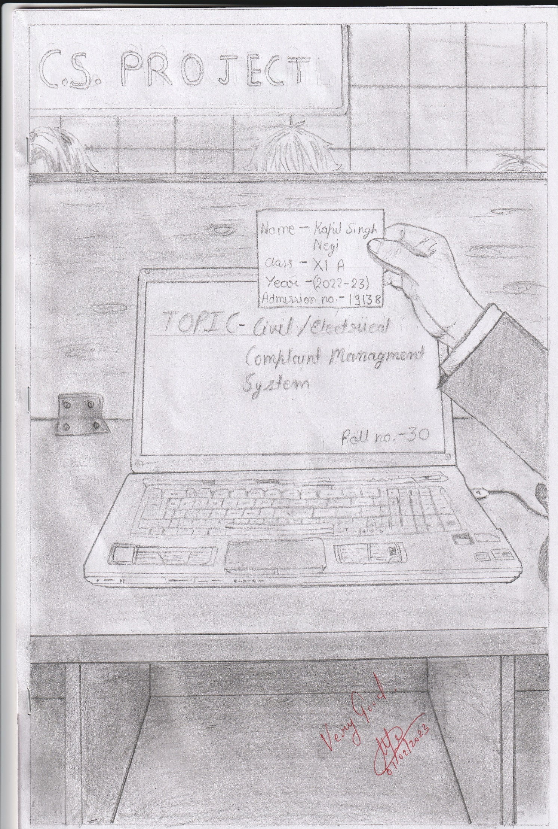



Under the guidance of

Mrs. Alpa Biju,

Subject Teacher,

Delhi Public School-Bopal,

Ahmedabad - 380 058.

Submitted by

KAPIL SINGH NEGI

CLASS – XI –A

Admission number: 19138

**Index**

|  |  |  |
| --- | --- | --- |
| **S. No.** | **Particulars** | **Page No.** |
| **1.** | **Certificate** | **03** |
| **2.** | **Acknowledgement** | **04** |
| **3.** | **System Requirement Hardware/ Software** | **05** |
| **4.** | **Purpose of Creating Projects** | **06** |
| **5.** | **Coding** | **07** |
| **6.** | **Screen Shots** | **16** |
| **7.** | **Bibliography / References** | **21** |



**COMPUTER PROJECT CERTIFCATE**

This is to certify that this project is made by **KAPIL SIGNH NEGI** of class **XI section A**, on the topic “**Project Report on Civil / Electrical Complain System**”. The project has been successfully completed under the guidance of subject teacher Ms. Alpa Biju as a part of his class XI annual project submission for the year 2022 – 23.

**Date:**

**Signature of Subject Teacher School Stamp**

**Acknowledgement**

*It has been a great privilege to have Mrs. Alpa Biju, Computer Techer, DPS, Bopal Ahmedabad as my computer teacher and guide. I express sincere gratitude to madam for her invaluable guidance, constructive criticism, and suggestions for encouraging me throughout the project. I am obliged to all my DPS teachers whose active cooperation, unfailing support enable me to complete the project.*

***KAPIL SINGH NEGI***

*XI – A*

*Admission No: 19138*

*D.P.S. Bopal, Ahmedabad-380 058*

**System Requirement Hardware/ Software**

**Hardware Specification:**

* X86 64-bit CPU(intel/AMD architecture)
* 4 GB RAM
* 5 GB free disk space

**Software:**

Language/s Used: Python Programming

Python version (Recommended): 3.8

**Purpose of Creating Projects**

**Introduction:**

Civil / Electrical Complaint Management System provides way of solving the problems faced by the customer by saving time with smooth functioning.

**Objective:**

The objective of the Civil / Electrical Complaint Management System is to make Complains easier to coordinate, monitor, and resolve, and to provide Customer with an effective tool to identify and target problem areas, monitor Complaint handling performance and make improvements. Complaint management programme/project is used to record, resolve and respond to Customer Complaint and requests.

**Overall Complaint Handling Process Flow Chart**

**Stage-1**

**Receiving the Complaint**

**Stage-2**

**Accessing the Complaint**

**Stage-3**

**Investigating the Complaint**

**Stage-4**

**Resolving the Complaint**

**Coding**

dict_civilian = {'kapil': ['kapil2006@', '1A', '976XX XXXX0'], 'aditya': ['aditya200$', '1B', '816XX XXXX7']}  
l_civilian = ['kapil', 'aditya']  
dict_worker = {'plumber': ["adi234", '849XX XXXX8'], 'electrician': ['goda987', '456XX XXXX9'],  
 'carpenter': ['bau567', '678XX XXXX4'], 'painter': ['kamal890', '596XX XXXX4'],  
 'cleaner': ['ohm789', '655XX XXXX4'], 'welder': ['hemu452', '458XXX XXX7']}  
l_worker = ['plumber', 'electrician', 'carpenter', 'painter', 'cleaner', 'welder']  
while True:  
 a = 3  
 name = input("\nUsername: ")  
 if name not in (l_civilian + l_worker) and name != 'admin':  
 print('username not in records, try again \n', '-'*80)  
 continue  
 print("please enter your password")  
 while True:  
 if a == 0 and name != 'admin':  
 if name in l_civilian:  
 del dict_civilian[name], l_civilian[l_civilian.index(name)]  
 elif name in l_worker:  
 del dict_worker[name], l_worker[l_worker.index(name)]  
 print("\nyour 3 attempts are up, you are now banned.")  
 print("please contact the server moderator for further info-")  
 print("email address: abc_morderator@gmail.com \nph.number: 978XXX XXX7 \n", '='*80)  
 break  
 elif a == 0 and name == 'admin':  
 print("\nfor multiple incorrect attempts you have been logged out")  
 print("please recheck the password and try again later", '-'*80)  
 break  
 password = input("Password (or exit): ")  
 if password == 'exit':  
 print('='*80)  
 break  
 elif name in dict_civilian and dict_civilian[name][0] == password:  
 while True:  
 pr_c = dict_civilian[name][3:]  
 print("\nwelcome", name, 'what do you wish to do..?')  
 print('1. Check profile \n2. Report a problem \n3. log out \n')  
 choice_1 = int(input('enter choice: '))  
 if choice_1 == 1:  
 while True:  
 print('-' * 80, '\nprofile-\n\nName: ', name, '\nblock number: ', dict_civilian[name][1])  
 print('registered mobile number: ', dict_civilian[name][2])  
 print('pending requests: ', str(pr_c).count('pending'))  
 print("\nwhat do you wish to do..?\n1. check pending requests\n2. check completed requests")  
 print("3. go back")  
 choice_0 = int(input('\nenter choice: '))  
 if choice_0 == 1:  
 flag = 0  
 print('-'*80, '\nlist of pending requests-')  
 for i in pr_c:  
 if i[2] == "pending":  
 print(str(pr_c.index(i)+1) + ".", i[1])  
 print(" assigned worker:", i[0])  
 flag = 1  
 if flag == 0:  
 print("NO PENDING REQUESTS")  
 h = input("\npress enter to go back")  
 elif choice_0 == 2:  
 flag = 0  
 print('-'*80, "\nlist of requests completed-")  
 for j in pr_c:  
 if j[2] == "completed":  
 print(str(pr_c.index(j) + 1) + ".", j[1])  
 print(" confirmed by:", j[0])  
 flag = 1  
 if flag == 0:  
 print("NO REQUESTS COMPLETED")  
 m = input("\npress enter to exit")  
 elif choice_0 == 3:  
 print('-'*80)  
 break  
 else:  
 print('invalid choice, enter again')  
 elif choice_1 == 2:  
 while True:  
 print('-' * 80)  
 problem = input("\nwhat seems to be the issue?\n>")  
 print("\nlist of workers-")  
 for i in range(1, len(l_worker)+1):  
 print(str(i)+". ", l_worker[i-1])  
 t = int(input("\nenter choice: "))  
 if t <= len(l_worker):  
 (dict_civilian[name]).append([l_worker[t-1], problem, "pending"])  
 dict_worker[l_worker[t-1]].append((name, problem))  
 print("request sent\n", "-"*80)  
 else:  
 print('Invalid choice, please recheck and enter again\n')  
 continue  
 break  
 elif choice_1 == 3:  
 print("\nyou are now logged out \n", "="*80)  
 break  
 else:  
 print('invalid choice enter again\n', '-'*80)  
 continue  
 break  
 elif name in dict_worker and dict_worker[name][0] == password:  
 while True:  
 pr_w = dict_worker[name][2:]  
 print("\nwelcome employee,", name, ' \nwhat do you wish to do..?')  
 print("1. check profile \n2. check pending requests \n3. sign out\n")  
 choice_2 = int(input("enter choice: "))  
 if choice_2 == 1:  
 print("-"*80, "\nprofile-\naccount: ", name, "\nregistered mobile number: ", dict_worker[name][1])  
 print("requests pending: ", len(pr_w))  
 x = input("\npress enter to go back")  
 print("-"*80)  
 elif choice_2 == 2:  
 while True:  
 print("-" * 80, "\nrequests log-")  
 if len(pr_w) != 0:  
 for i in range(len(pr_w)):  
 print(str(i + 1) + ".", "requested by: ", pr_w[i][0])  
 else:  
 print("no requests pending")  
 k = input("\npress enter to go back")  
 print('-'*80)  
 break  
 print("\nwhat do you wish to do..?")  
 print("(1-" + str(i + 1) + "). check for more details\n " + str(i + 2) + " . go back")  
 n = int(input("\nenter choice: "))-1  
 if n in range(i+1):  
 print('-'*80, "\nrequest -", pr_w[n][1], "\nrequested by-", pr_w[n][0])  
 print("block number-", dict_civilian[pr_w[n][0]][1])  
 print("phone number-", dict_civilian[pr_w[n][0]][2])  
 while True:  
 print("\nwhat do you wish to do..?\n1. report completion\n2. go back")  
 g = int(input("\nenter choice: "))  
 if g == 1:  
 x = dict_civilian[pr_w[n][0]].index([name, pr_w[n][1], "pending"])  
 dict_civilian[pr_w[n][0]][x][2] = "completed"  
 del pr_w[n], dict_worker[name][n+2]  
 print('completion confirmed')  
 x = input("\npress enter to go back")  
 break  
 elif g == 2:  
 print("-"*80)  
 break  
 else:  
 print("invalid choice, enter again\n", '-'*80)  
 elif n == i+1:  
 print('-'*80)  
 break  
 else:  
 print("invalid choice, enter again")  
 elif choice_2 == 3:  
 print("\nyou are now logged out\n", '='*80)  
 break  
 else:  
 print("invalid choice, enter again\n", "-"*80)  
 break  
 elif name == 'admin' and password == 'admin2468':  
 while True:  
 print("\nwelcome administrator, what do you wish to do..?")  
 print("1. edit dict_civilian\n2. view dict_civilian\n3. edit dict_worker\n4. view dict_worker")  
 print("5. server shutdown\n6. log out\n")  
 choice_3 = int(input("enter choice: "))  
 if choice_3 == 1:  
 while True:  
 print('-'*80, "\n\nwhat do you wish to do..?")  
 print("1. add account\n2. remove account\n3. go back")  
 choice_4 = int(input('\nenter choice: '))  
 if choice_4 == 1:  
 print("\ninput details of the account-")  
 w = input("enter the username: ")  
 x = input("enter the password: ")  
 y = input("enter block number: ")  
 z = input("enter phone number: ")  
 dict_civilian[w] = [x, y, z]  
 l_civilian.append(w)  
 print("\naccount added")  
 elif choice_4 == 2:  
 u = input("\nenter account username: ")  
 if u in l_civilian:  
 del dict_civilian[u], l_civilian[l_civilian.index(u)]  
 print("account deleted")  
 else:  
 print("name not in records")  
 elif choice_4 == 3:  
 print('-'*80)  
 break  
 else:  
 print("invalid choice, enter again\n", '-'*80)  
 elif choice_3 == 2:  
 print('-'*80, '\ndict_civilian-')  
 for i in dict_civilian:  
 j = 11 - len(i)  
 k = 11 - len(dict_civilian[i][0])  
 print("\n", i, ' '*j, ':', dict_civilian[i][:3], ' '*k, "\n\trequests pending:")  
 for x in range(len(dict_civilian[i][3:])):  
 print('\t', x+1, ". ", dict_civilian[i][3+x])  
 x = input("\npress enter to go back")  
 print('-'*80)  
 elif choice_3 == 3:  
 while True:  
 print('-'*80, "\n\nwhat do you wish to do..?\n1. add account\n2. remove account\n3. go back")  
 choice_5 = int(input('\nenter choice: '))  
 if choice_5 == 1:  
 print("\ninput details of the account-")  
 x = input("enter the username: ")  
 y = input("enter the password: ")  
 z = input("enter phone number: ")  
 dict_worker[x] = [y, z]  
 l_worker.append(x)  
 print("\naccount added")  
 elif choice_5 == 2:  
 u = input("enter account username: ")  
 if u in l_worker:  
 del dict_worker[u], l_worker[l_worker.index(u)]  
 print("account deleted")  
 else:  
 print("name not in records")  
 elif choice_5 == 3:  
 print('-'*80)  
 break  
 else:  
 print("invalid choice, enter again\n", '-'*80)  
 elif choice_3 == 4:  
 print('-'*80, '\ndict_worker-')  
 for i in dict_worker:  
 j = 11-len(i)  
 k = 10-len(dict_worker[i][0])  
 print(i, ' '*j, ':', dict_worker[i][:2], ' '*k, "; due requests:", dict_worker[i][2:])  
 x = input("\npress enter to go back")  
 print('-'*80)  
 elif choice_3 == 5:  
 print('-'*80, "\n\nenter 'CONFIRM' if you really want to shut the server down")  
 x = input("> ")  
 if x == 'CONFIRM':  
 print("\nTHE SERVER HAS BEEN SHUT DOWN\n", '*'*80)  
 exit()  
 else:  
 print("\nsince you entered '", x, "' instead of ' CONFIRM '\nthe server shout down is aborted")  
 x = input("\npress enter to go back")  
 print('-'*80)  
 elif choice_3 == 6:  
 print("\nyou are now logged out\n", '='*80)  
 break  
 else:  
 print('invalid choice, enter again\n', '-'*80)  
 break  
 else:  
 if a != 1:  
 print("\nincorrect password, try again\nyou have", a-1, "chances left\n", '-'*80)  
 else:  
 print("\nincorrect password\nyou have", a - 1, "chances left")  
 a -= 1

**Screen Shots**

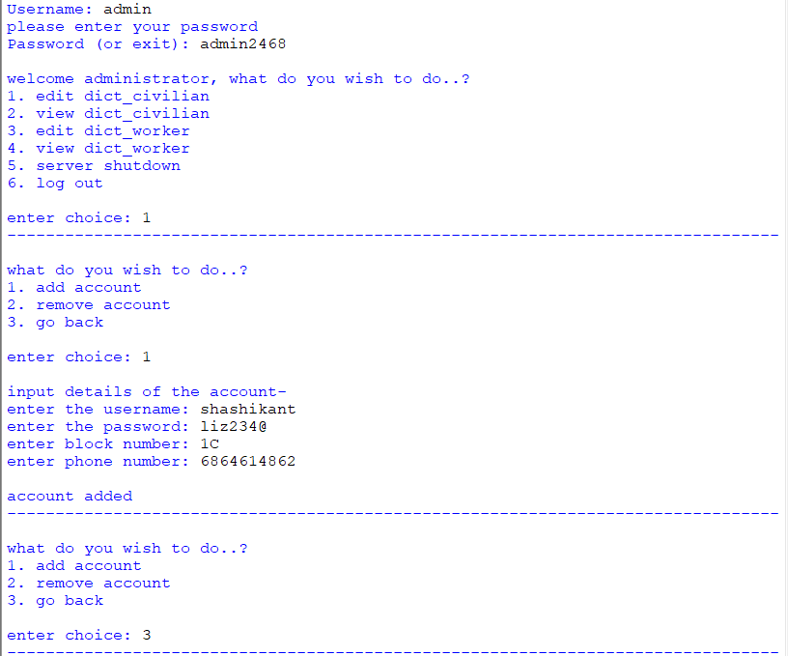

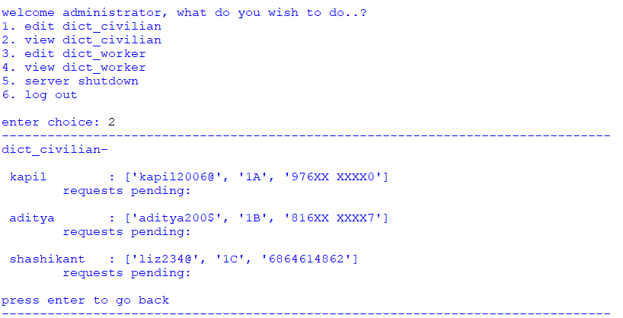

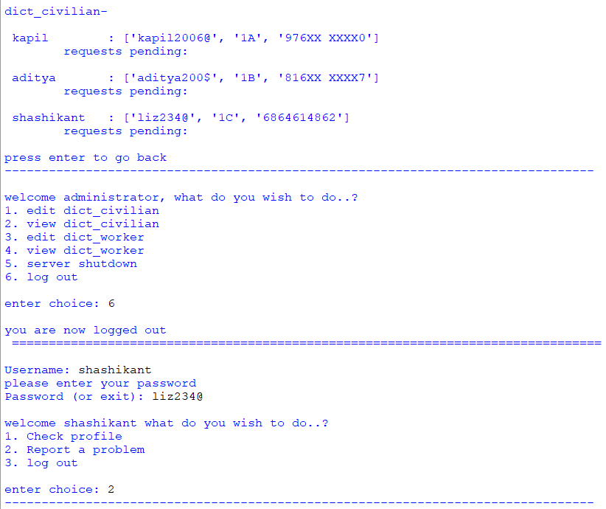

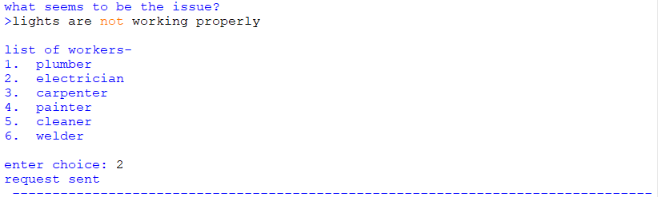

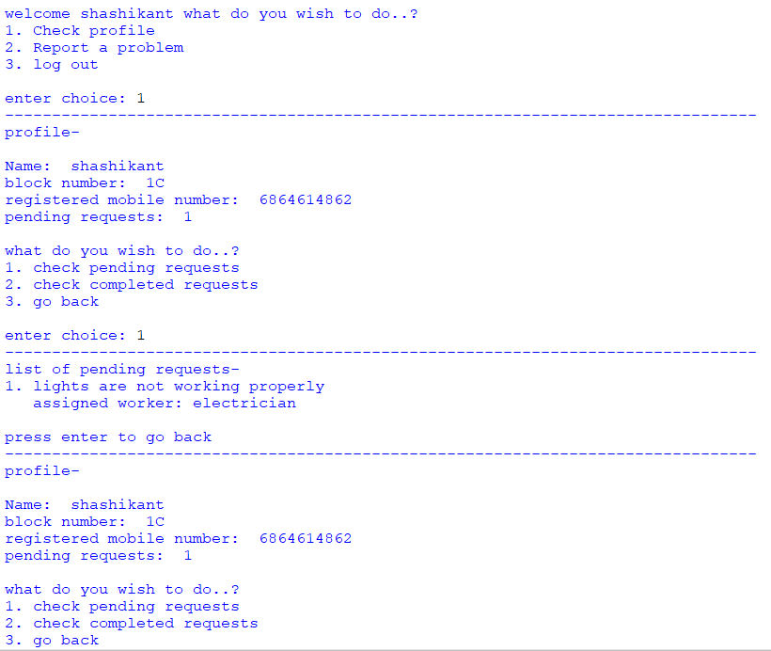

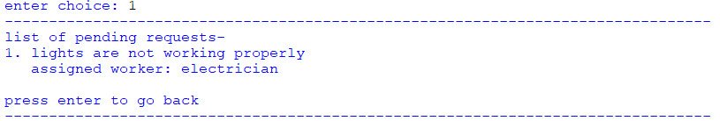

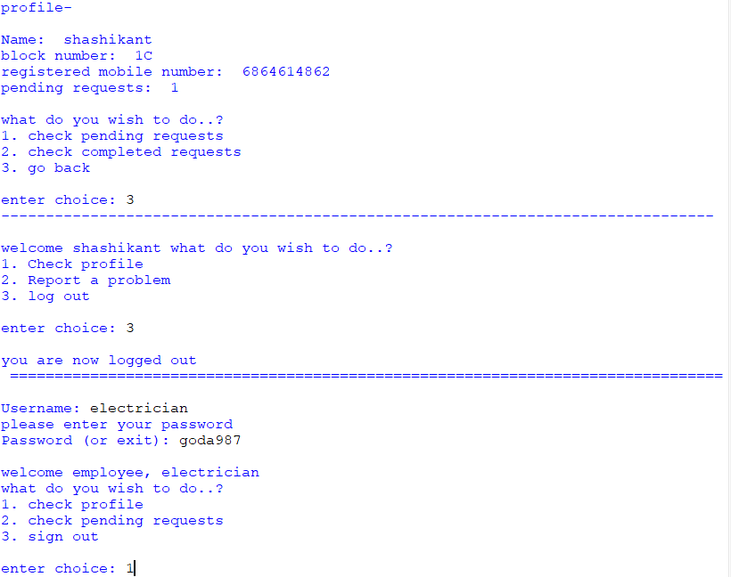

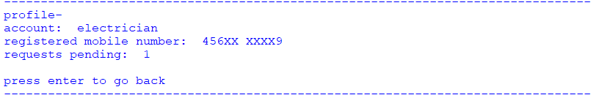

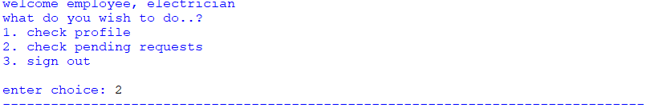

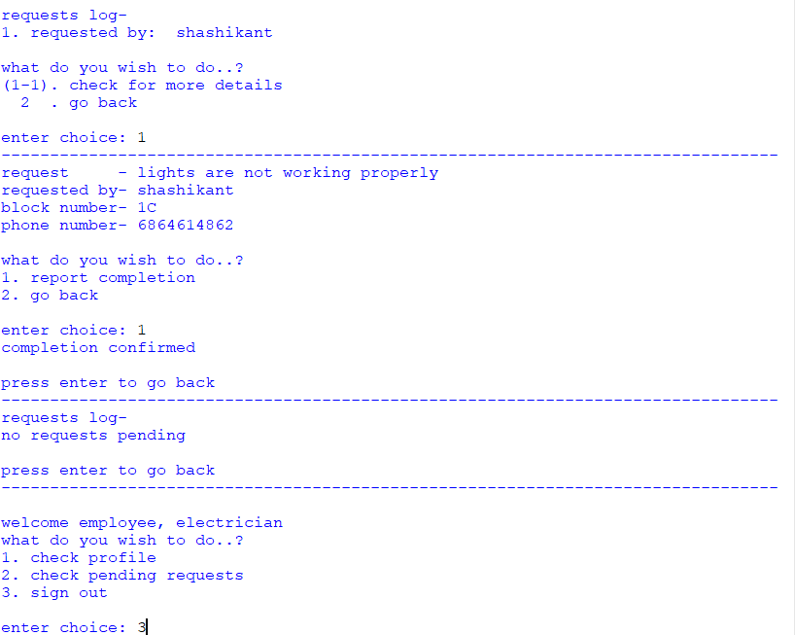

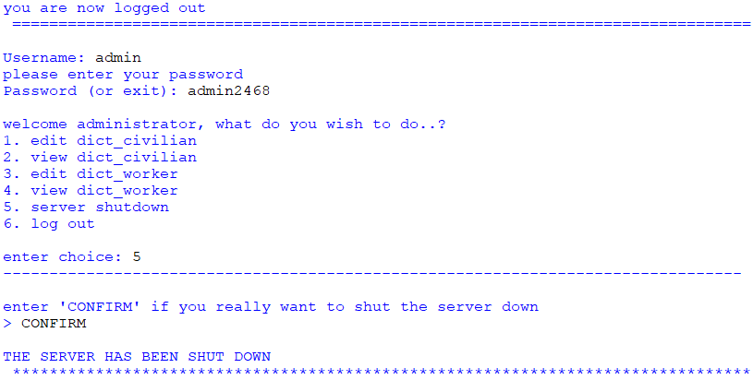

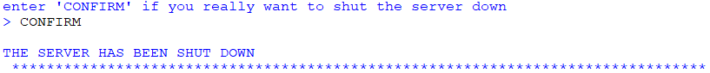

Bibliography / References

1. Arora, Sumita., Computer science with Python: Textbook for class XI. New Delhi: Dhanpat Rai & Co. (P), Ltd., 2020
2. Arora, Preeti, Computer Science with python: Textbook for class-XI. New Delhi: Sultan Chand & Sons (P) Ltd., 2022
3. Thareja, Reema., Python Programming; using problem solving approach, New Delhi: Oxford University Press, 2022.

*****